Raising Custom errors
In python, we can raise custom errors by using the `raise` keyword.
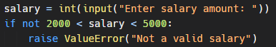

In the previous tutorial, we learned about different built-in exceptions in Python and why it is important to handle exceptions. However, sometimes we may need to create our own custom exceptions that serve our purpose.
Defining Custom Exceptions
In Python, we can define custom exceptions by creating a new class that is derived from the built-in Exception class.

Here's the syntax to define custom exceptions:
